Day 1 – Summer Internship
Introduction
My first day of internship was all about setting up my development environment, learning GitHub, and publishing my first portfolio website. Each step is documented with screenshots, making this a complete record of my journey.

Step 1: Searching GitHub
I began by searching for GitHub to understand its features and importance in collaborative coding.
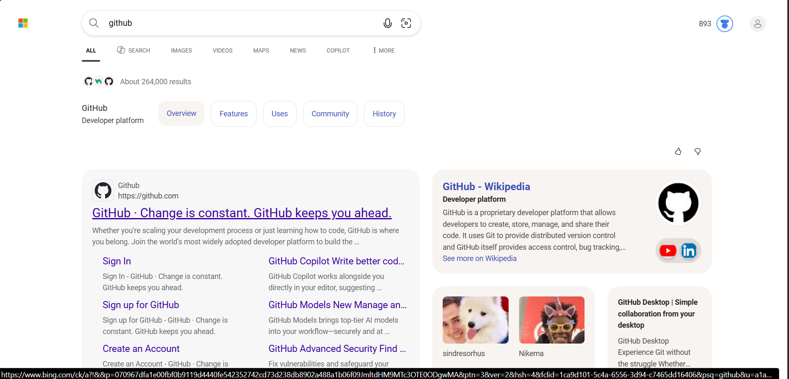

Step 2: Signing Up on GitHub
I created my GitHub account by entering my email and signing up.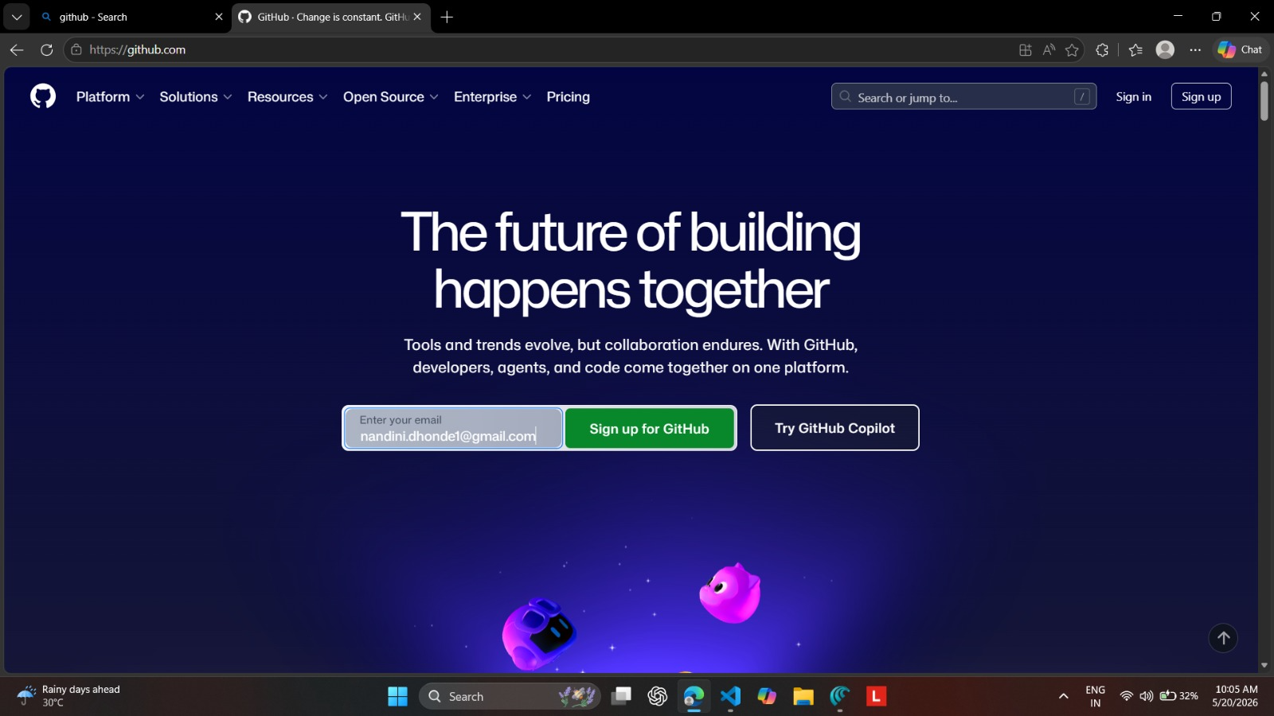
Step 3: Logging Into GitHub
I logged in with my credentials to access repositories and developer tools
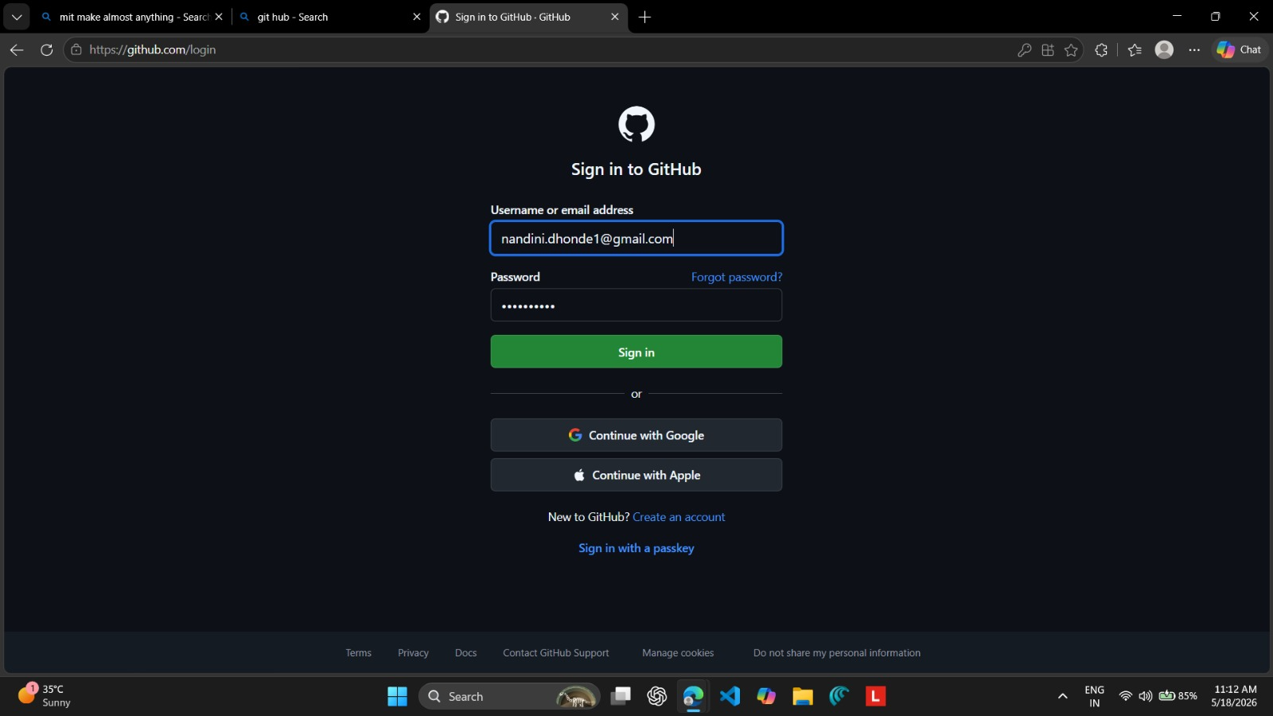

Step 4: Installing Visual Studio Code
I downloaded and installed VS Code, my main coding editor.
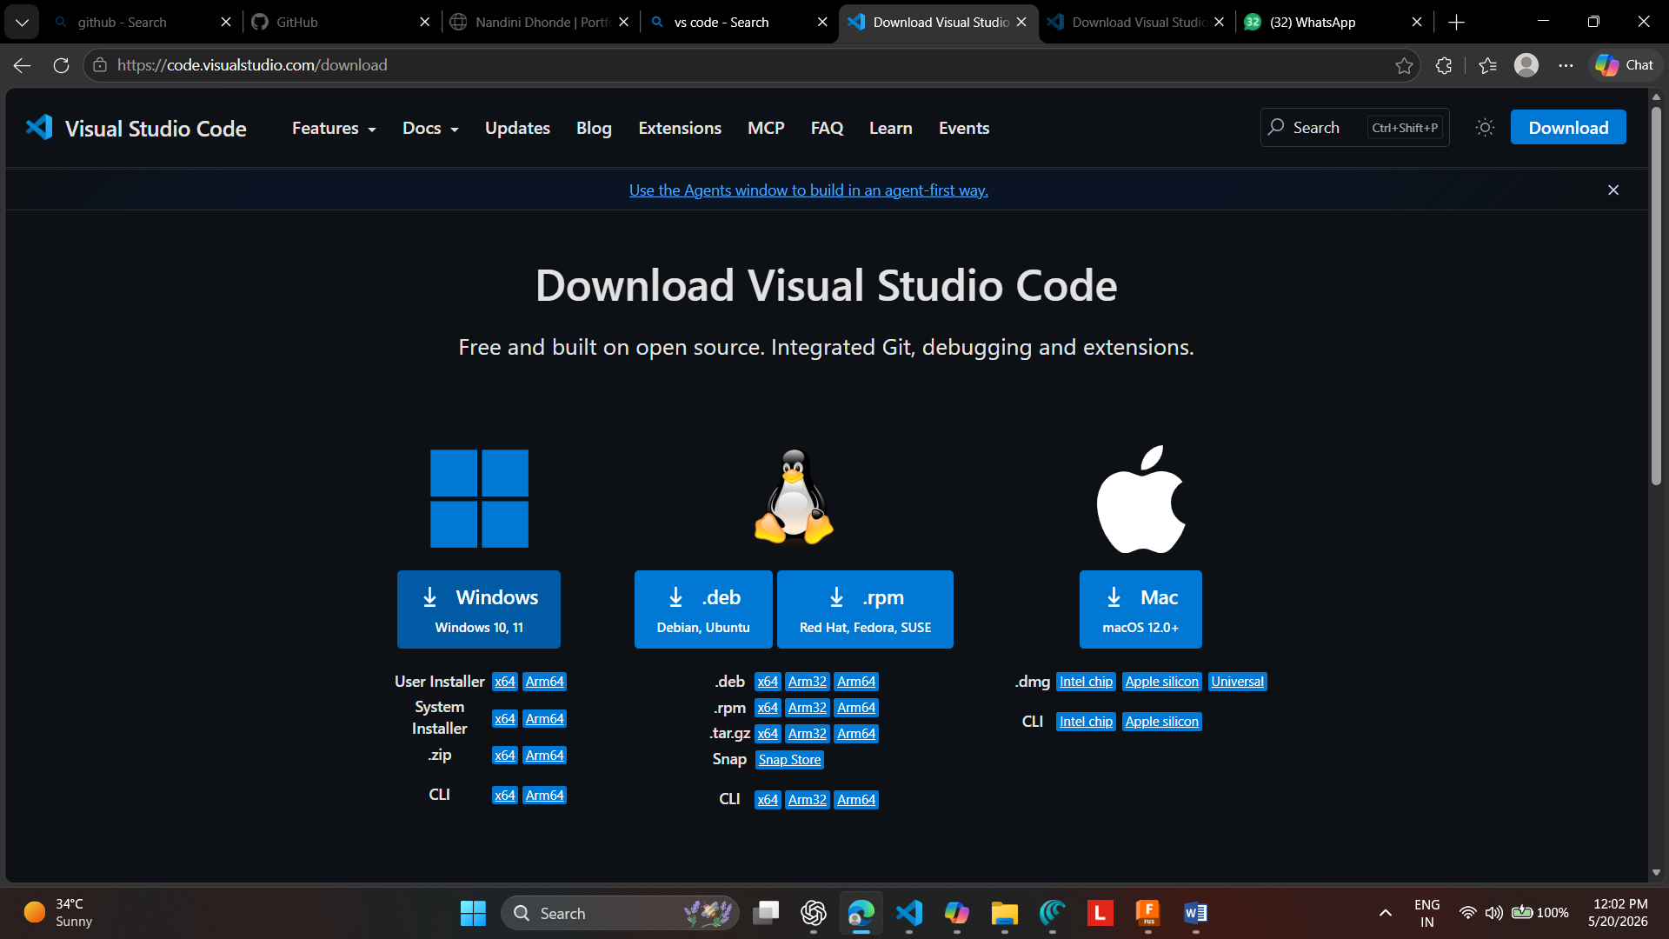

Step 5: Setting Up VS Code
I customized VS Code with extensions and settings to prepare my workspace.

Step 6: Installing Live Server Extension
I installed the Live Server extension to preview my web projects in real time.

Step 7: Creating the Portfolio Website Folder
To stay organized, I created a folder named “portfolio-website.”
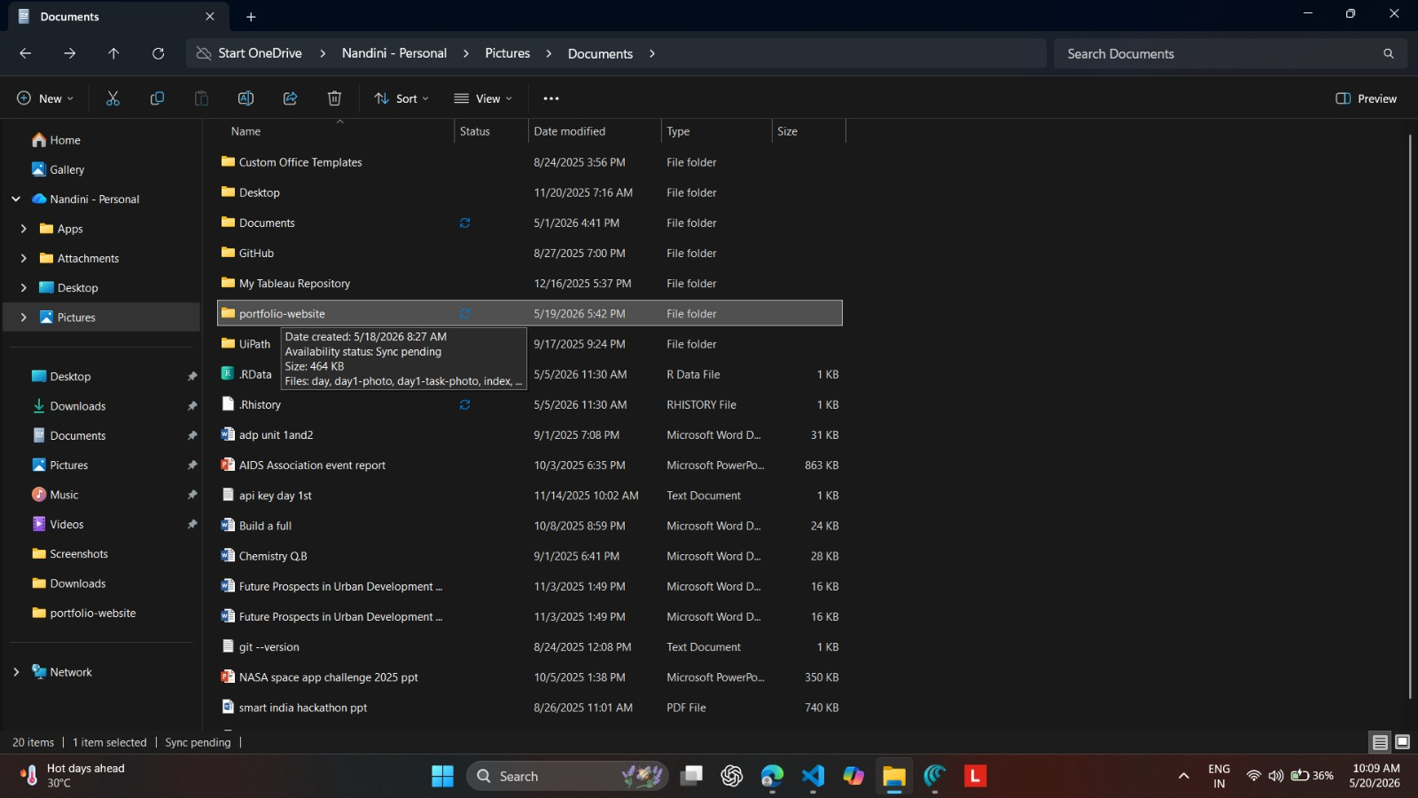

Step 8: Opening the Folder in VS Code
I opened the portfolio-website folder in VS Code to begin coding.
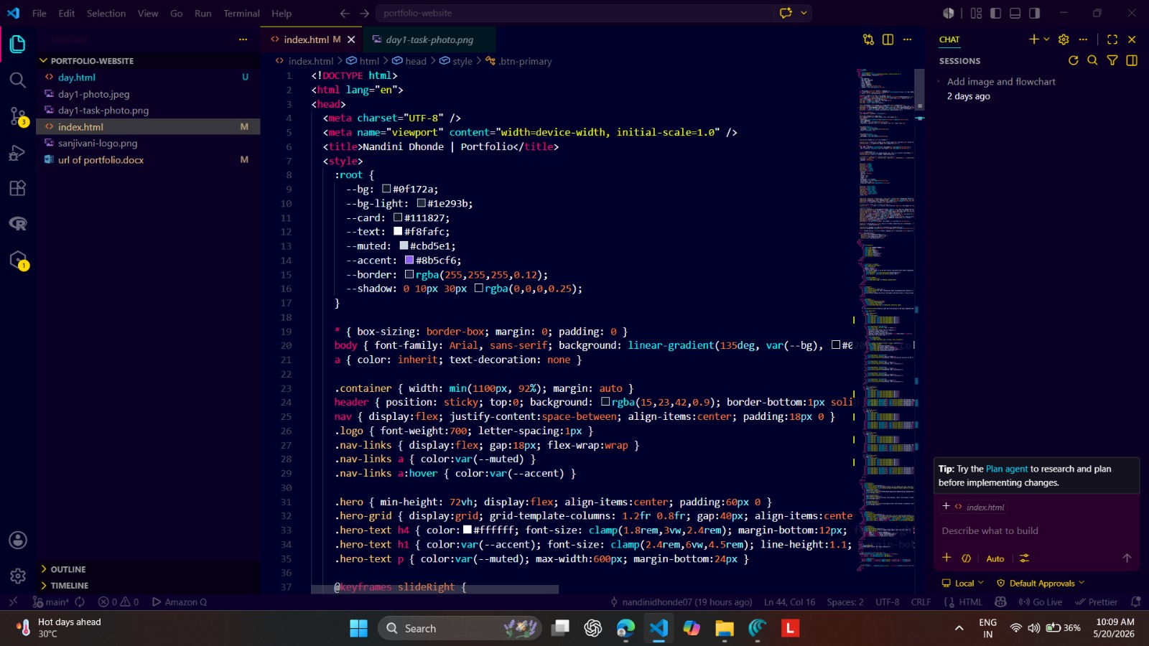

Step 9: Creating a GitHub Repository
I created a repository named “TI_intern_Nandini” to store my project online.
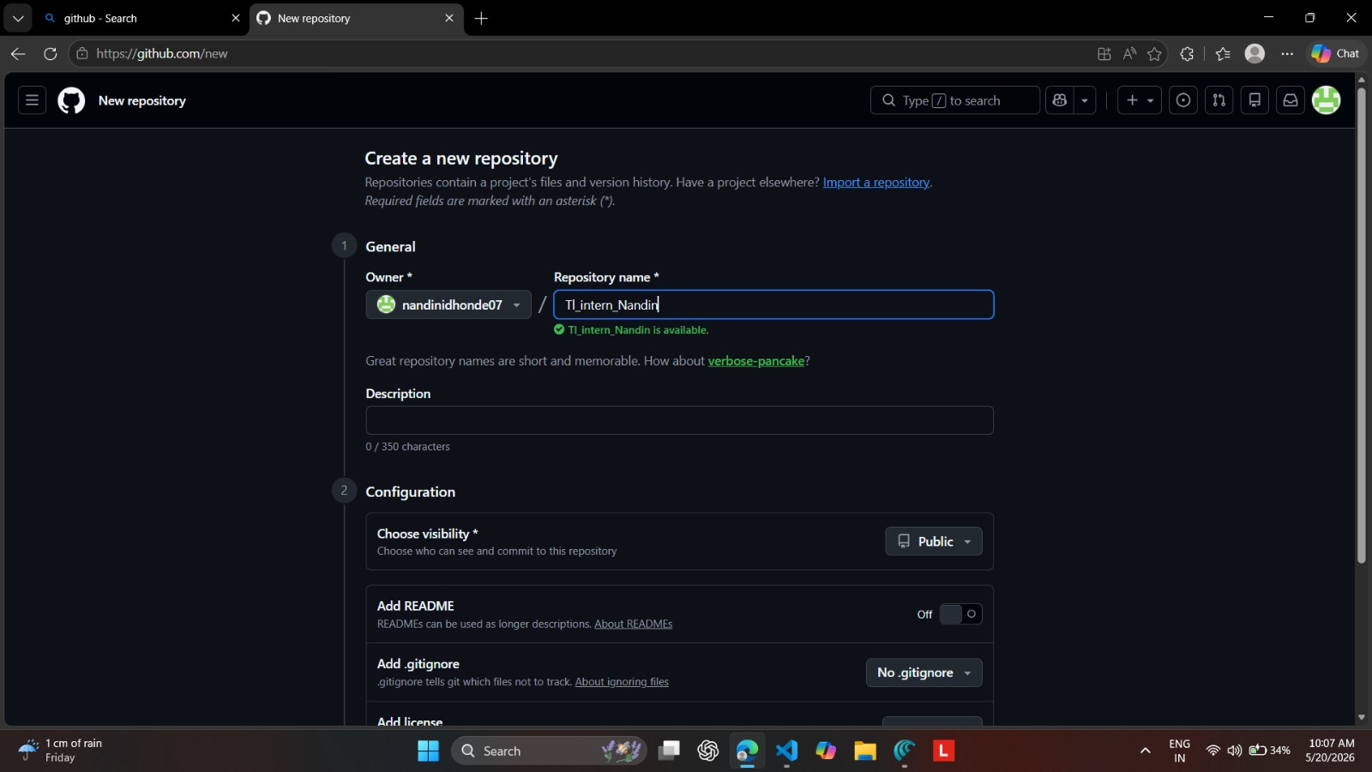

Step 10: Coding My Portfolio Website
I wrote HTML and CSS code for my portfolio, adding my photo and the Tinkerers’ Lab logo.


Step 11: Pushing Code to GitHub
I used Git commands (git add ., git commit, git push) to upload my portfolio to GitHub
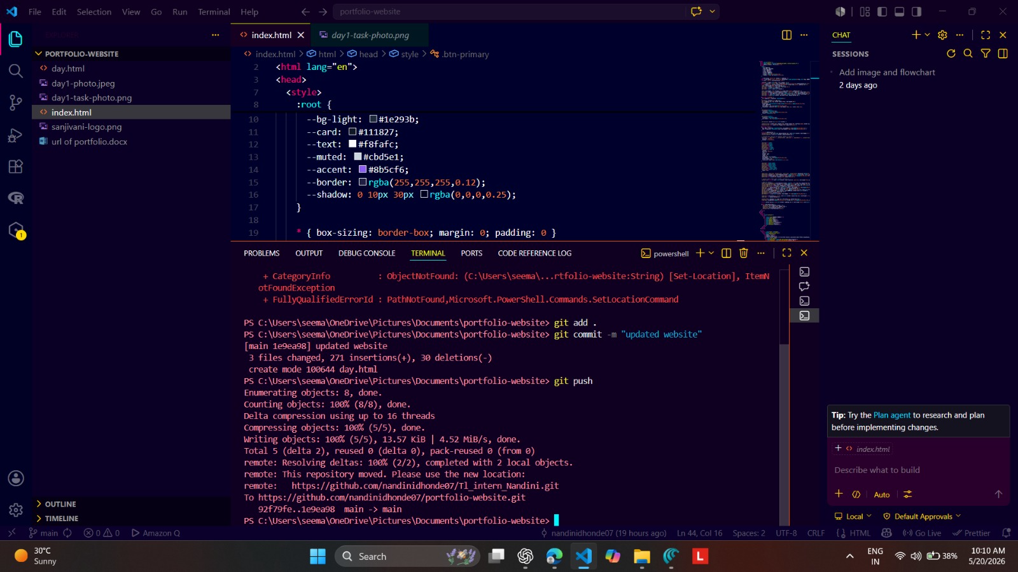

Step 12: Updating and Pushing Changes Again
I refined my design and pushed updates again using Git commands.
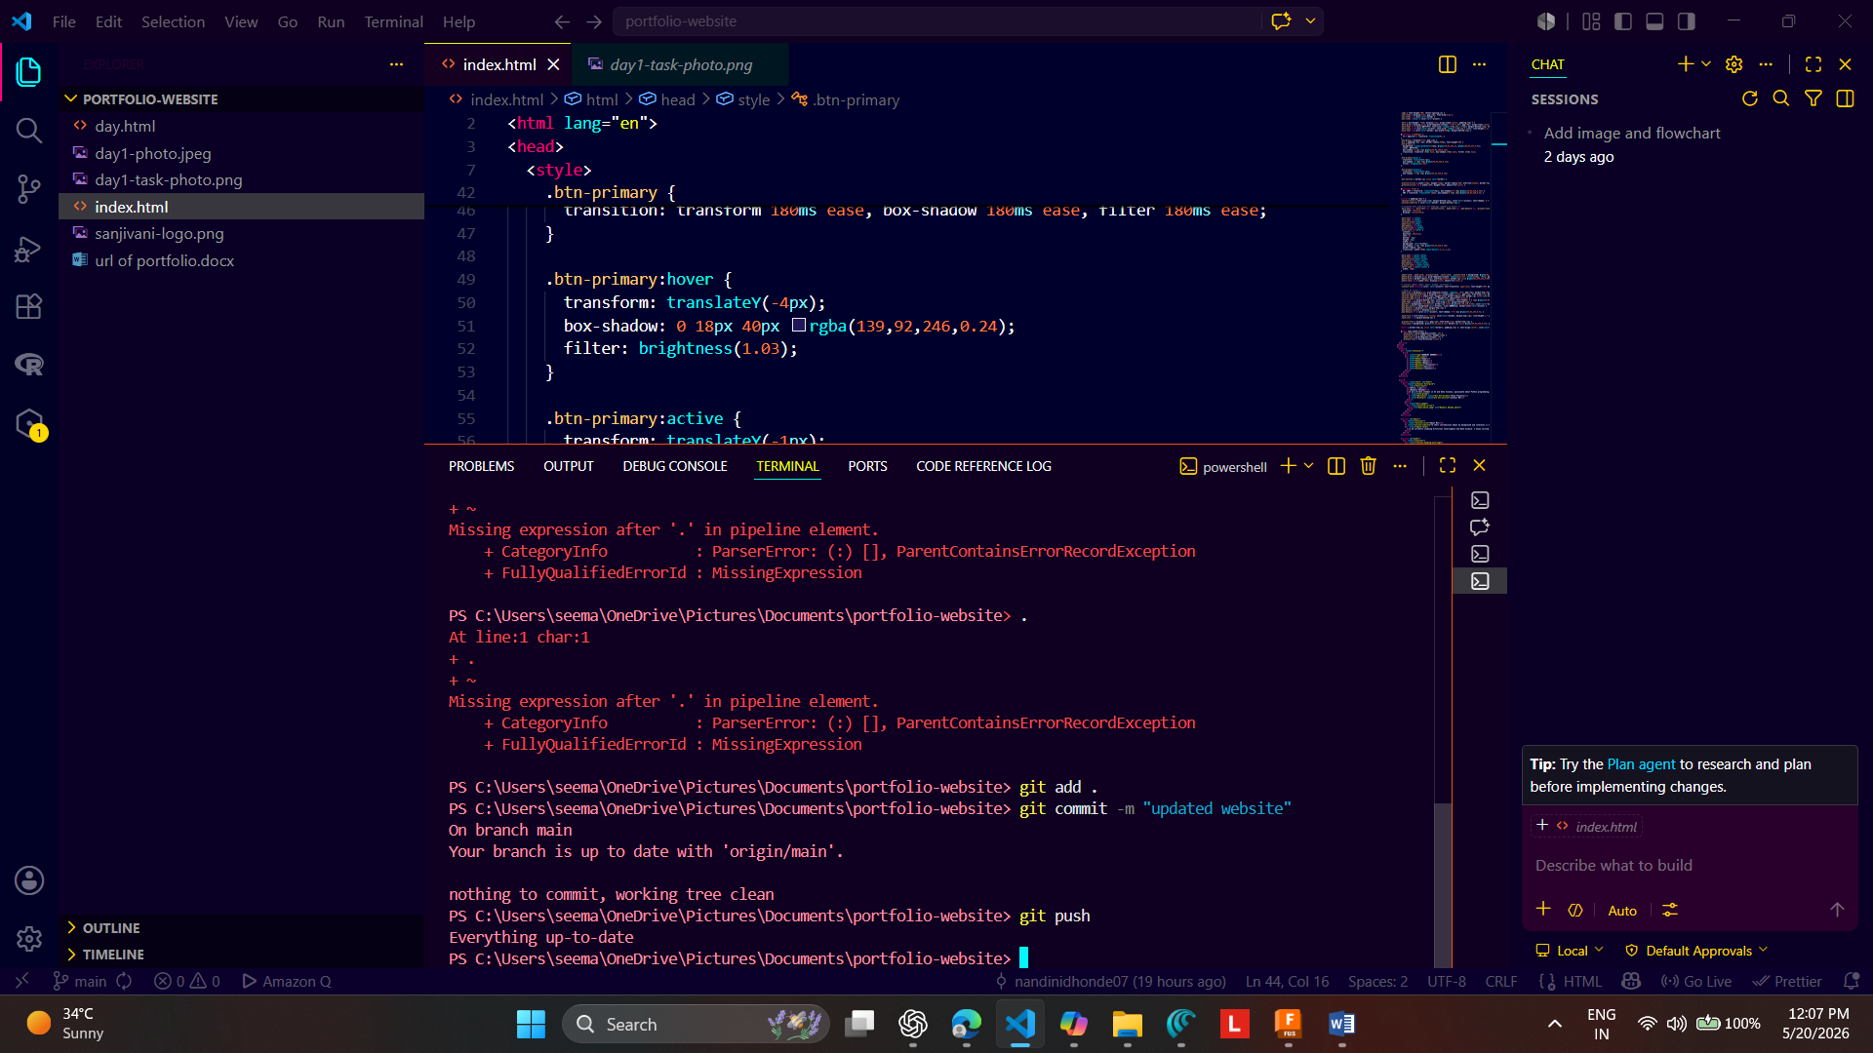

Step 13: Configuring Repository Settings
I explored repository settings, adjusting the default branch and other options
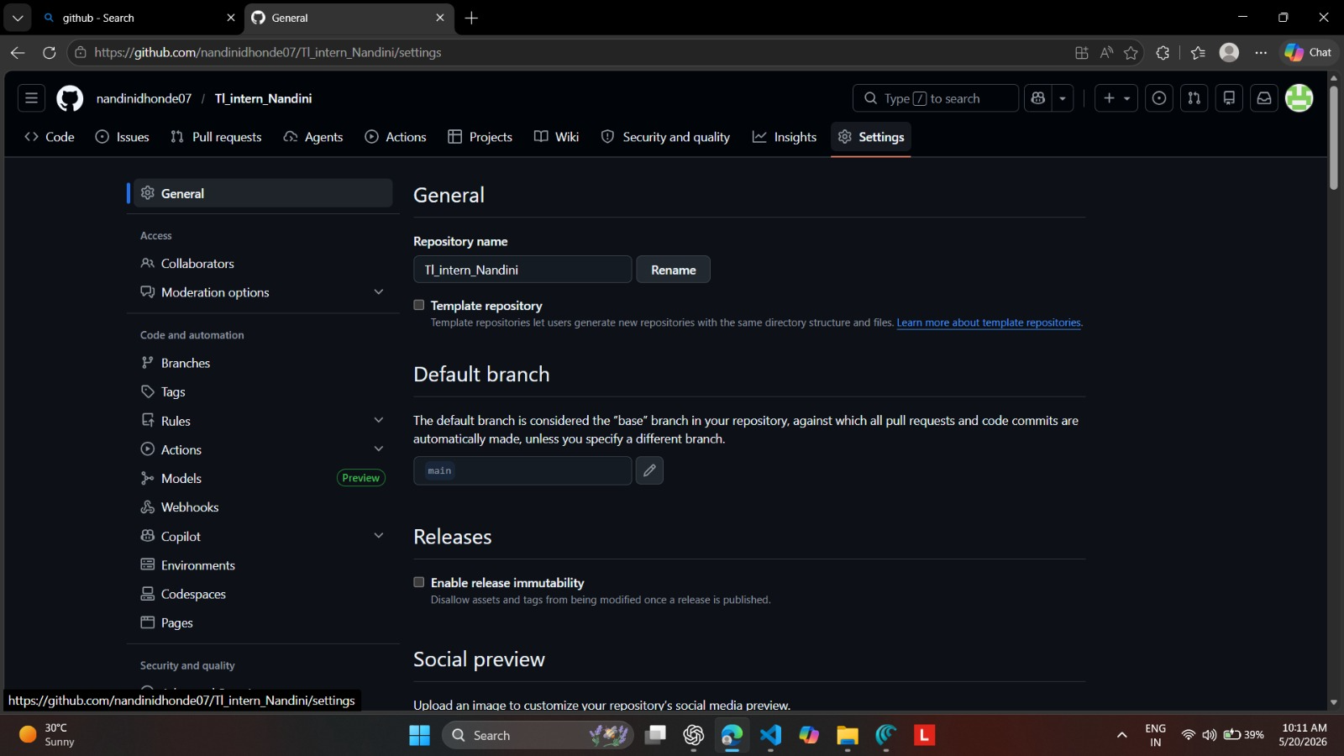

Step 14: Enabling GitHub Pages
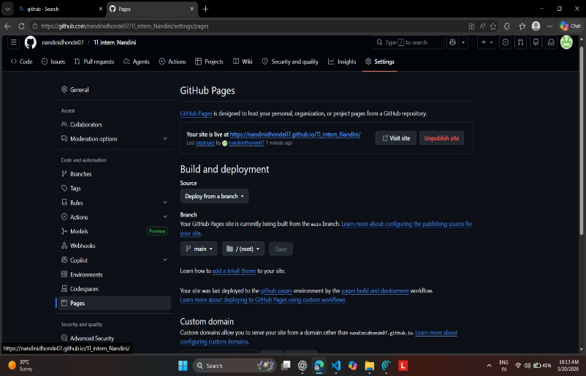
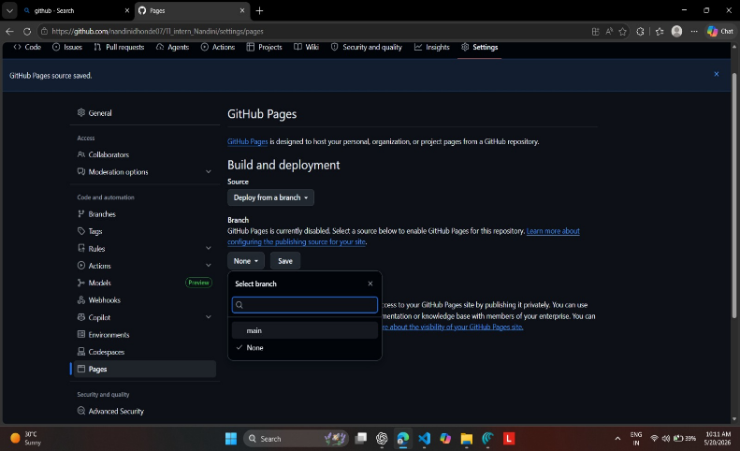
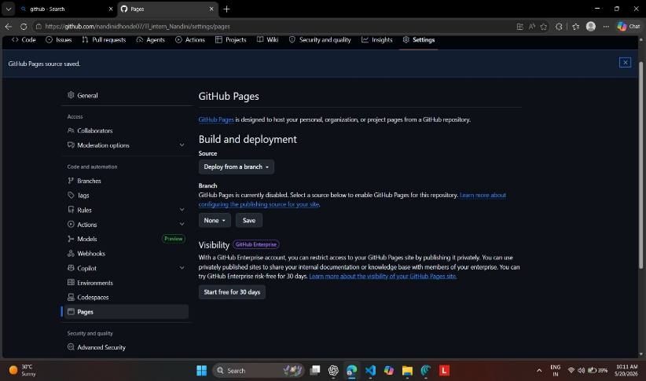
I enabled GitHub Pages to host my portfolio website directly from the repository.
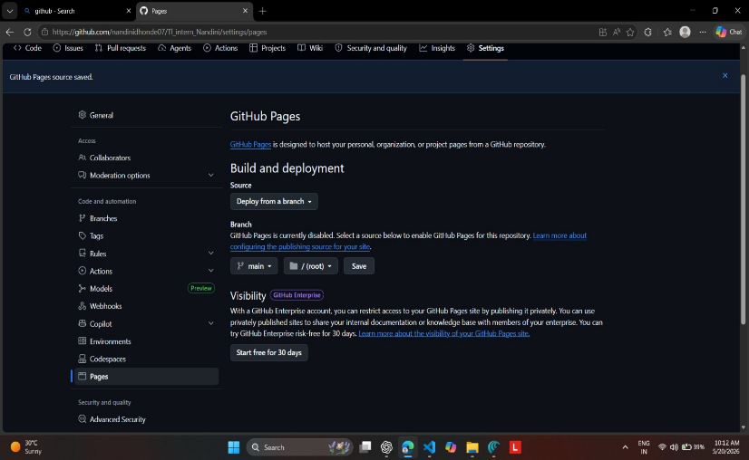

Step 15: Publishing My Portfolio Website
Finally, my site went live at: https://nandindihonde07.github.io/TI_intern_Nandini/
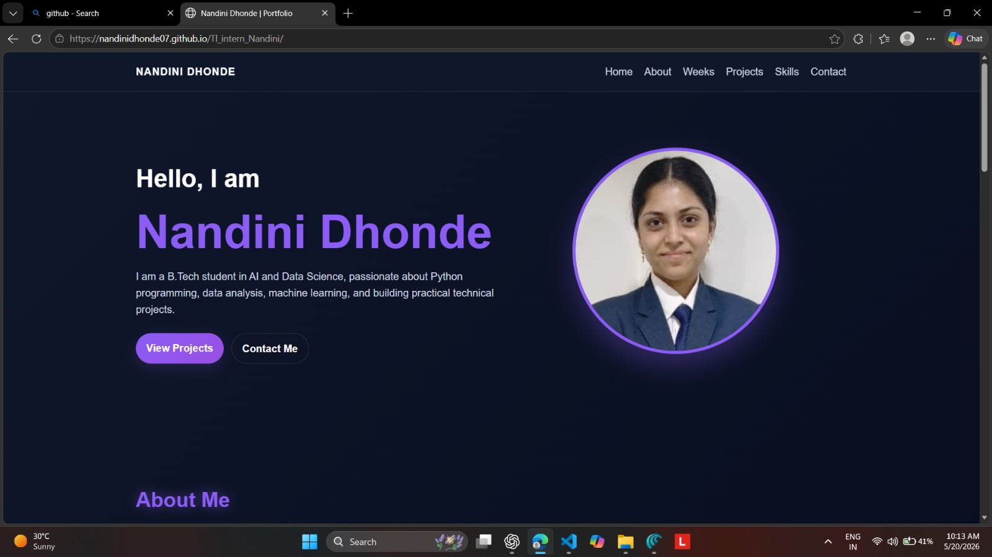

Conclusion
Day 1 was a complete journey from setup to deployment:
- I created and managed my GitHub account and repository.
- Installed and configured VS Code with Live Server.
- Organized my files and coded a portfolio website.
- Pushed my work to GitHub and published it live using GitHub Pages.

Reflection
Day 1 was a complete journey from setup to deployment. I learned how to:
- Manage repositories and version control with GitHub.
- Configure a coding environment with VS Code.
- Apply Git commands for professional workflow.
- Deploy a live website using GitHub Pages.
This gave me confidence and a strong foundation for the rest of my internship. My portfolio website is not just a project — it’s a record of my growth, where I can save tasks for each week and each day.

References
- ChatGPT (Microsoft Copilot) – for guidance and support.
- Google Search – for exploring GitHub, VS Code, and related documentation.
- YouTube Tutorials – for practical demonstrations of GitHub and VS Code setup.
- The Comet – for additional insights and reference material.

